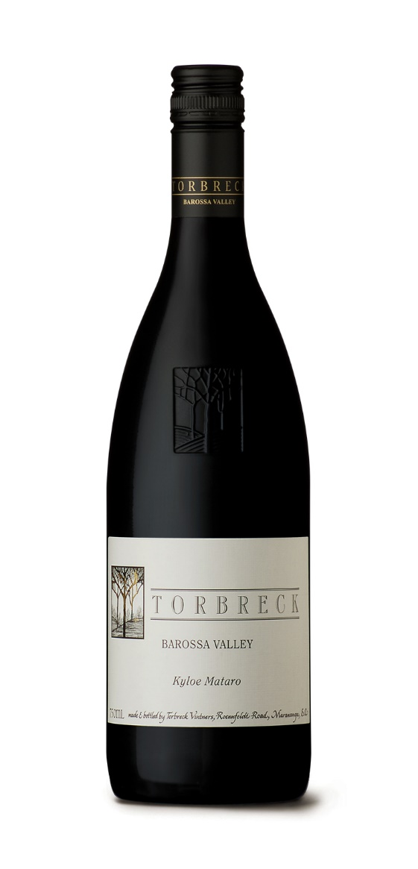

VARIETY: 100% Mataro
SUB-REGIONS: Seppeltsfield, Greenock
HARVEST: 5th – 11th April 2024
maturation: 18 months 4500L French oak Foudre
AnaLYSIS: Alc/Vol 15%
pH 3.55
Acidity 5.96g/L
COLOUR: Deep crimson
AROMA: blackberry, red cherry, black olive, charcuterie and beef jerky.
PALATE: Firm, fleshy and round with long acids and textural mouthfeel balanced by plush tannins and excellent palate length.
CELLAR: Drink now or cellar for up to 5 years

A Kyloe or Highland Cow is a wild and hardy beast.
This single varietal Mataro is fitting of the breed.

All Torbreck wines rely on great terroir and great viticulture, but the third and equally significant quality factor is the time when the fruit leaves the vineyard – the picking date.
This is particularly true for Mataro, where patience is required to ensure physiological and flavour ripeness is achieved, regardless of the sugar levels in the fruit.

This restraint is rewarded with dense, wild and completely rounded wines made from fruit that has reached the optimum stage of flavour development. The climate in the Barossa Valley is perfectly suited to achieving this level of ripeness and is a place where we truly believe some of the best Mataro wines in the world can be made.
VINTAGE
The lead up to the 2024 harvest saw timely spring rainfall and calm conditions for flowering and fruit set. A mild to warm summer was idyllic, propelling even growth and fruit development.
A warm early summer brought on shiraz showing bright colours and fragrance, persisting for several weeks accelerating to powerful dark fruit and fragrantly spiced characteristics. A cooler break mid-April allowed fruit to develop deep colours and firm tannins.
With harvest concluding on the 19th of April, we are extremely pleased with the strength and diversity of wines made from the 2024 season.
TASTING
Quite a savoury wine with aromas of wild black berries, black olive, dried red cherry and cured meats which are all further lifted with a complex array of morel mushroom, clove and wild game notes. At the heart of this wine is a soft plump cherry fruit core with a savoury edge giving the wine an earthy European like mouthfeel and appeal. A wine for enjoyment with game meats, lamb or vegetarian eggplant-based dishes like Greek moussaka or Provencale ratatouille. Serve at 16 C and enjoy up until 2032

